NEWBORN NUTRITION TEACHING PRESENTATION  FORMATION OF BREAST MILK  Lactation refers to the process of milk synthesis and secretion from the mammary glands. Lactiferous ducts found in the mammary glands help to transport breast milk (Napso et al., 2018). Prolactin is the hormone that facilitates the secretion of breast milk. Prolactin levels are elevated during pregnancy. They stimulate the proliferation of mammary gland tissues. The proliferation prepares the glands for milk production. During pregnancy, the action of prolactin is inhibited by estrogen and progesterone. During suckling, the levels of prolactin are increased leading to the stimulation of milk production (Napso et al., 2018). Increased amounts of prolactin are produced at night. Breastfeeding at this time can be advantageous because there is an enhanced milk supply.  Oxytocin hormone facilitates milk let-down. It contracts the myoepithelial cells and the milk is drained into the lactiferous ducts (Uvnas-Moberg et al., 2020). From the ducts, milk is ejected via the nipple pores. This hormone is produced within a short period compared to prolactin. The hormone is usually produced when the lactating mother expects to feed the baby and when the baby begins suckling. | 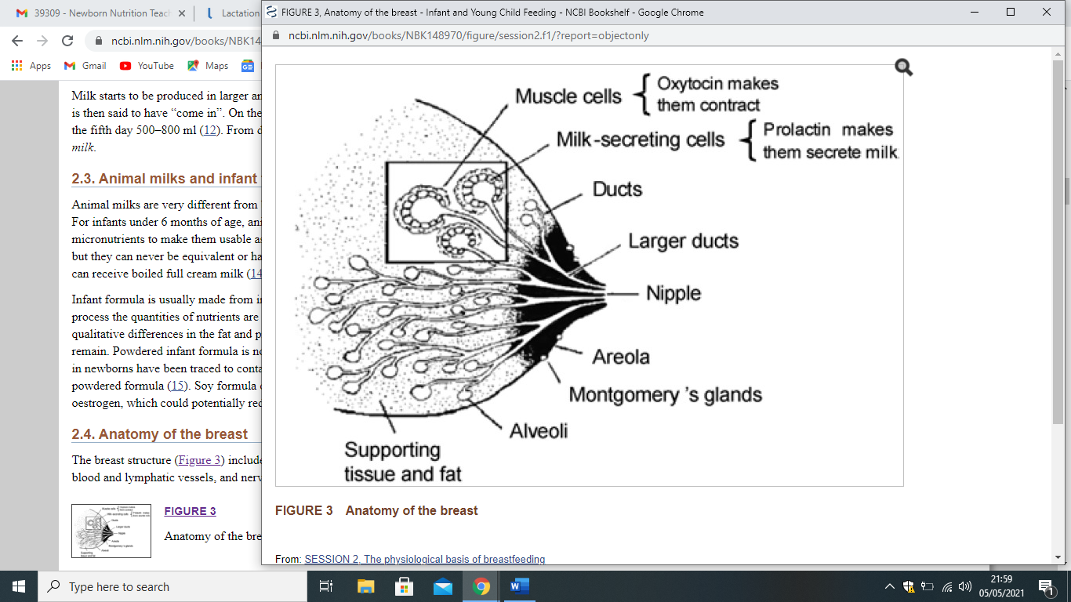  2020 NATIONAL HEALTH GOALS  The 2020 National Health Goals related to newborn nutrition to support breastfeeding as the best choice include:  - Exclusive breastfeeding through six months  - Increasing workplace lactation support programs  - Reducing the proportion of newborns who are given formula supplementation within the first two days of delivery.  Lactating women should learn the importance of breastfeeding and make the right informed decisions.  They should learn:  - How to breastfeed  - Challenges associated with breastfeeding  - How to pump and store breast milk  - Breastfeeding at the workplace, home, and other environments. |   NEWBORN NUTRITION TEACHING PRESENTATION
ADVANTAGES OF BREAST MILK RELATED TO IMMUNITY  Breast milk is enriched with all nutrients that baby requires to maintain their healthy state.  These nutrients include fats, proteins, carbohydrates, vitamins, water, and minerals (Toscano et al., 2017).  The fat content of breast milk is approximately 3 grams per 100 milliliters of milk. The main type of carbohydrate found in milk is lactose accounting for approximately 7 grams in every 100 milliliters (Toscano et al., 2017). The lower protein content in breast milk prevents overworking the immature renal system of the baby. Vitamins are available in adequate quantities. However, vitamin D should be provided to the baby by exposure to sunlight to trigger endogenous synthesis or through administering supplements (Okunola et al., 2018).  COMPONENTS THAT PROTECT AGAINST INFECTION  - Immunoglobulins  - Leucocytes  - Lactoferrin  - Lysozyme  - Oligosaccharides.  These components offer protection without causing any undesirable effects such as inflammation and fever.  Immunoglobulins contain antibodies against infections and bacteria that may have infected the mother (Toscano et al., 2017). Therefore, immunoglobulins offer protection against infections and bacteria that are likely to infect the baby. | BBBBBBBBBB  BBBBBBBBBBBBBBBBBBBBBBBBBBBBBBBBBBBBBBBBBBBBBBBBBBBBBBBBBBBBBBBBBBBBBBBBBBBBBBBBBBBBBBBBBBBBBBBBBBBBBB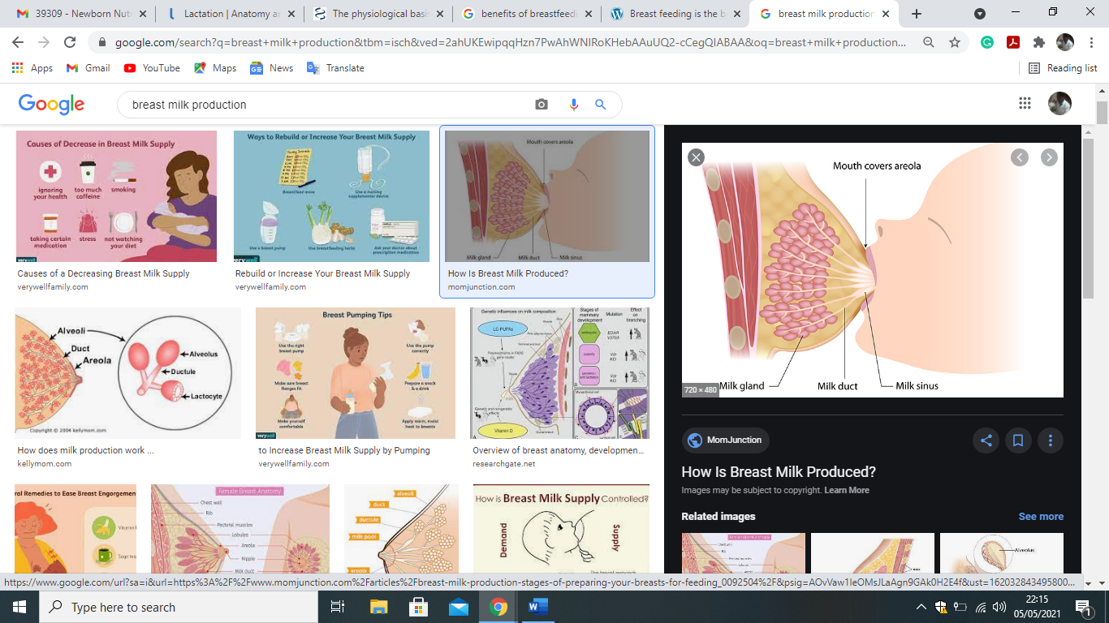BBBBBBBH  HJX  CC | BIOACTIVE FACTORS FOUND IN MILK  Bile-salt stimulated lipase – It enhances fat digestions after breast milk has been ingested (Toscano et al., 2017). This is contrary to artificial milk whose fat is not digested completely.  Epidermal growth factor- facilitates the maturation of the baby’s intestinal lining. This improves absorption and digestion and reduces the risk of infections (Toscano et al., 2017). Other growth factors present in breast milk facilitate the maturation of the retina.  ADDITIONAL BENEFITS OF BREASTFEEDING  It can be beneficial to the mother in various ways.  It promotes weight loss. Breastfeeding leads to the burning of approximately 500 calories per day. Women who breastfeed exclusively are most likely to burn more fats compared to those to do not breastfeed (Okunola et al., 2018).  Breastfeeding helps to enhance uterine contraction. The production of oxytocin during breastfeeding can help to facilitate uterine contractions (Uvnas-Moberg et al., 2020). This reduces the incidences of bleeding. Mothers who breastfeed exclusively are likely to lose lesser blood during subsequent deliveries.  Reduces the risk of postpartum depression- research has revealed that women who exclusively breastfeed have a lower risk of developing postpartum depression compared to those who do not breastfeed.

References.

Napso, T., Yong, H. E. J., Lopez-Tello, J., & Sferruzzi-Perri, A. N. (2018). The Role of Placental Hormones in Mediating Maternal Adaptations to Support Pregnancy and Lactation. Frontiers in Physiology, 9(AUG), 1–39. https://doi.org/10.3389/fphys.2018.01091
Ojo-Okunola, A., Nicol, M., & du Toit, E. (2018). Human Breast Milk Bacteriome in Health and Disease. Nutrients, 10(11), 1–13. https://doi.org/10.3390/nu10111643
Toscano, M., Grandi, R. De, Grossi, E., & Drago, L. (2017). Role of The Human Breast Milk-Associated Microbiota on the Newborns’ Immune System: A mini-review. Frontiers in Microbiology, 8(OCT), 1–5. https://doi.org/10.3389/fmicb.2017.02100
Uvnas-Moberg, K., Ekstrom-Bergstrom, A., Buckley, S., Massarotti, C., Pajalic, Z., Luegmair, K., Kotlowska, A., Lengler, L., Olza, I., Grylka-Baeschlin, S., Leahy-Warren, P., Hadjigeorgiu, E., Villarmea, S., & Dencker, A. (2020). Maternal Plasma Levels of Oxytocin During Breastfeeding-A Systematic Review. In PLoS ONE (Vol. 15, Issue 8 August 2020). https://doi.org/10.1371/journal.pone.0235806

